page1image384

D3: Brainstorming Report

Team One: Education

02/22/15

Informatics 131: Discussion A

Cassie Jeansonne 3914

Sophia Chan 6560

Sean Letzer 3320

Stevanus Iskandar 6911

TABLE OF CONTENTS

TABLE OF CONTENTS 2

PART 1: BRAINSTORMING SESSION PHOTOS 3

Diagram 1: Session One: Photo of Notes 3

Diagram 2: Session Two: Photo of Notes 3

Diagram 3: Session Three: Non Group Member 4

PART 2: BRAINSTORMING REFLECTION 5

PART 3: USER NEEDS AND REQUIREMENTS 6

PART 4: ALTERNATIVE IDEAS 8

PART 1: Brainstorming Session Photos

DIAGRAM 1: Session One Photo

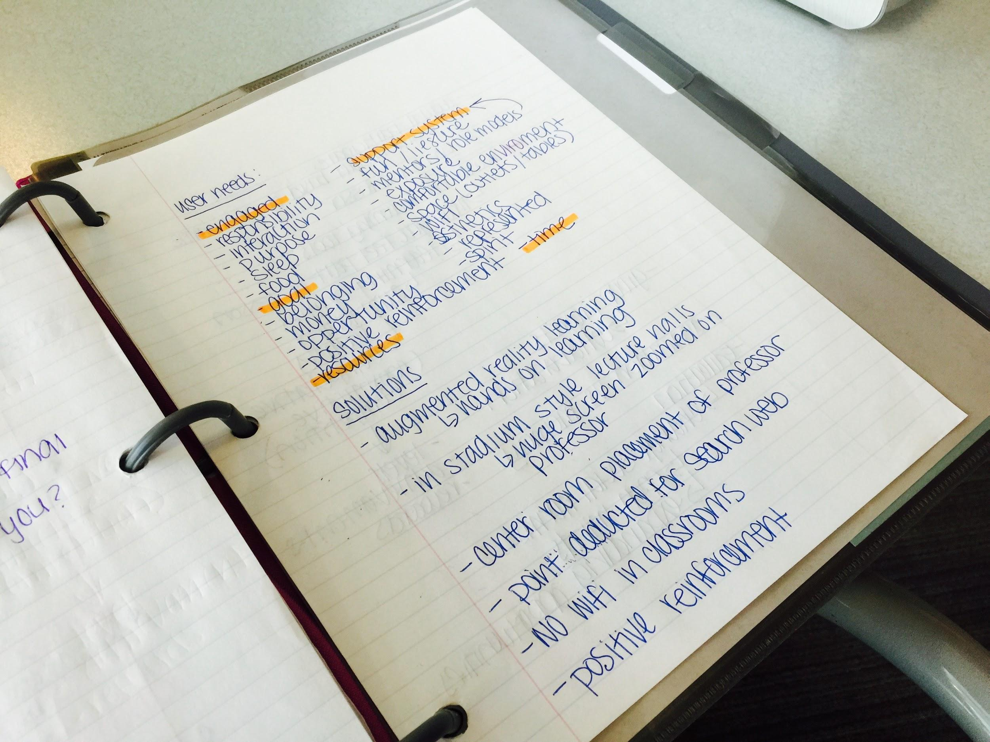

DIAGRAM 2: Session Two Photo

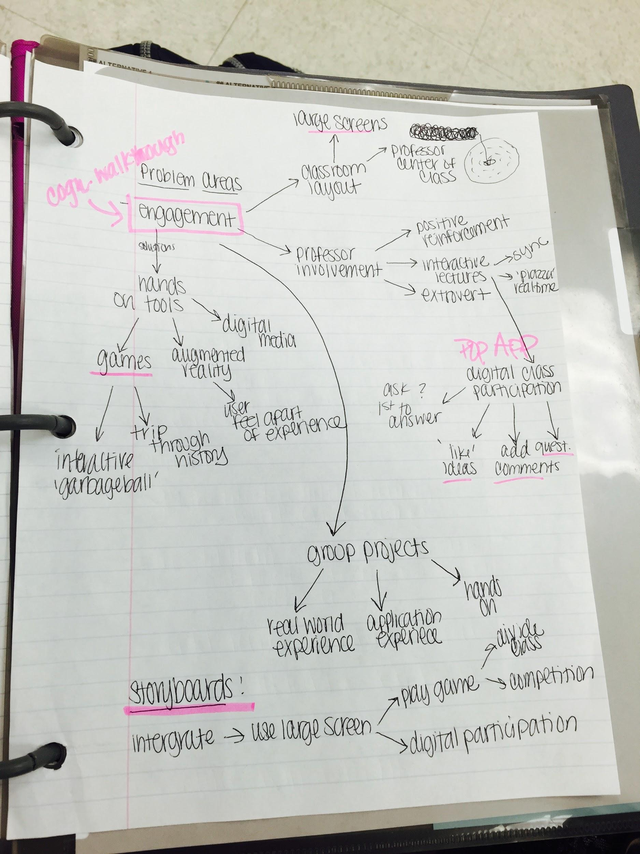

Diagram 3: Non Group Member Session

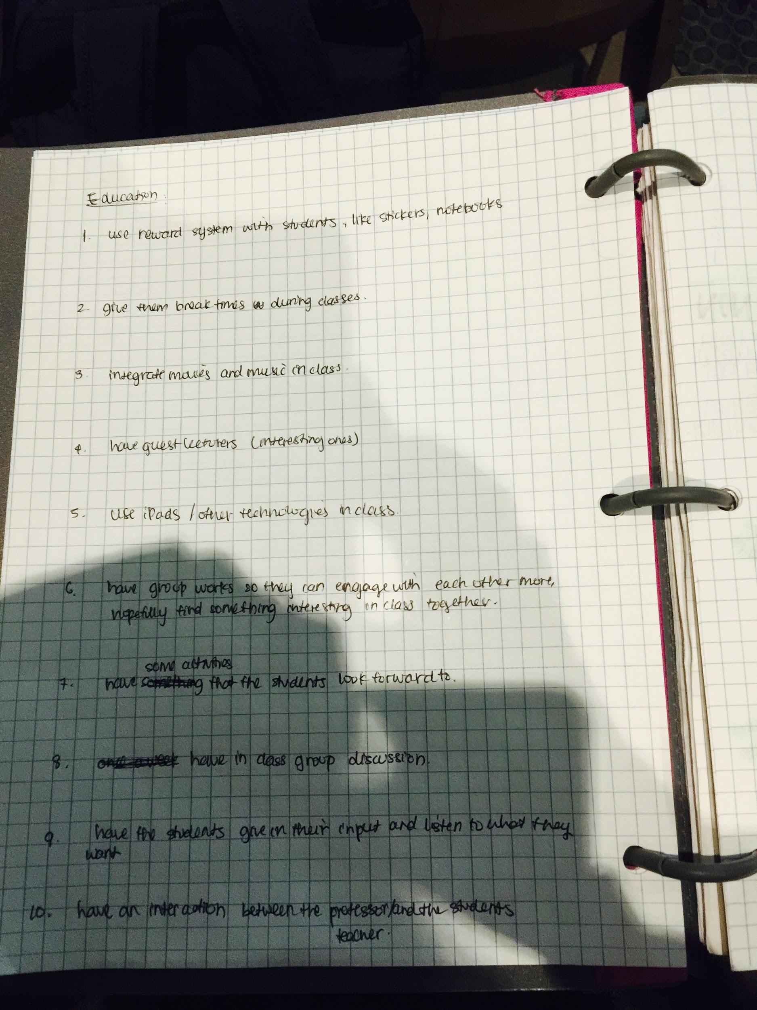

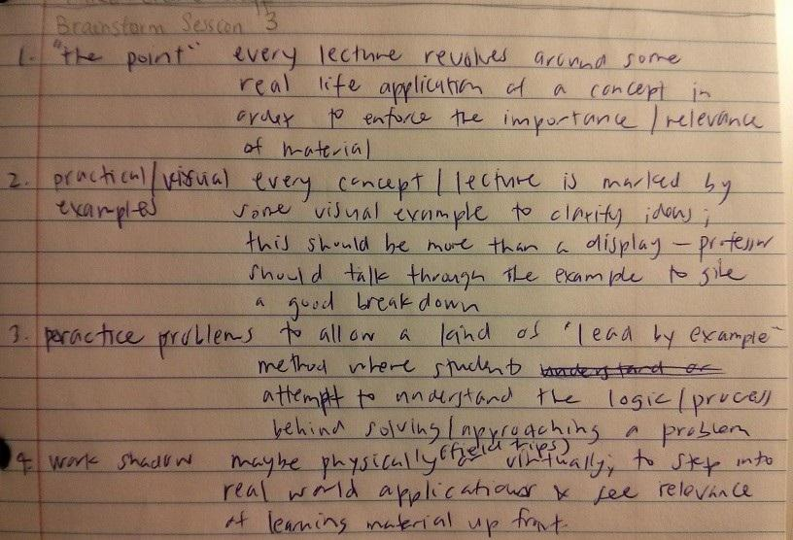

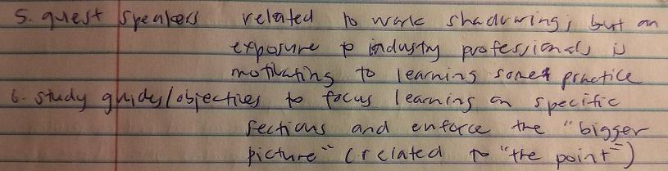

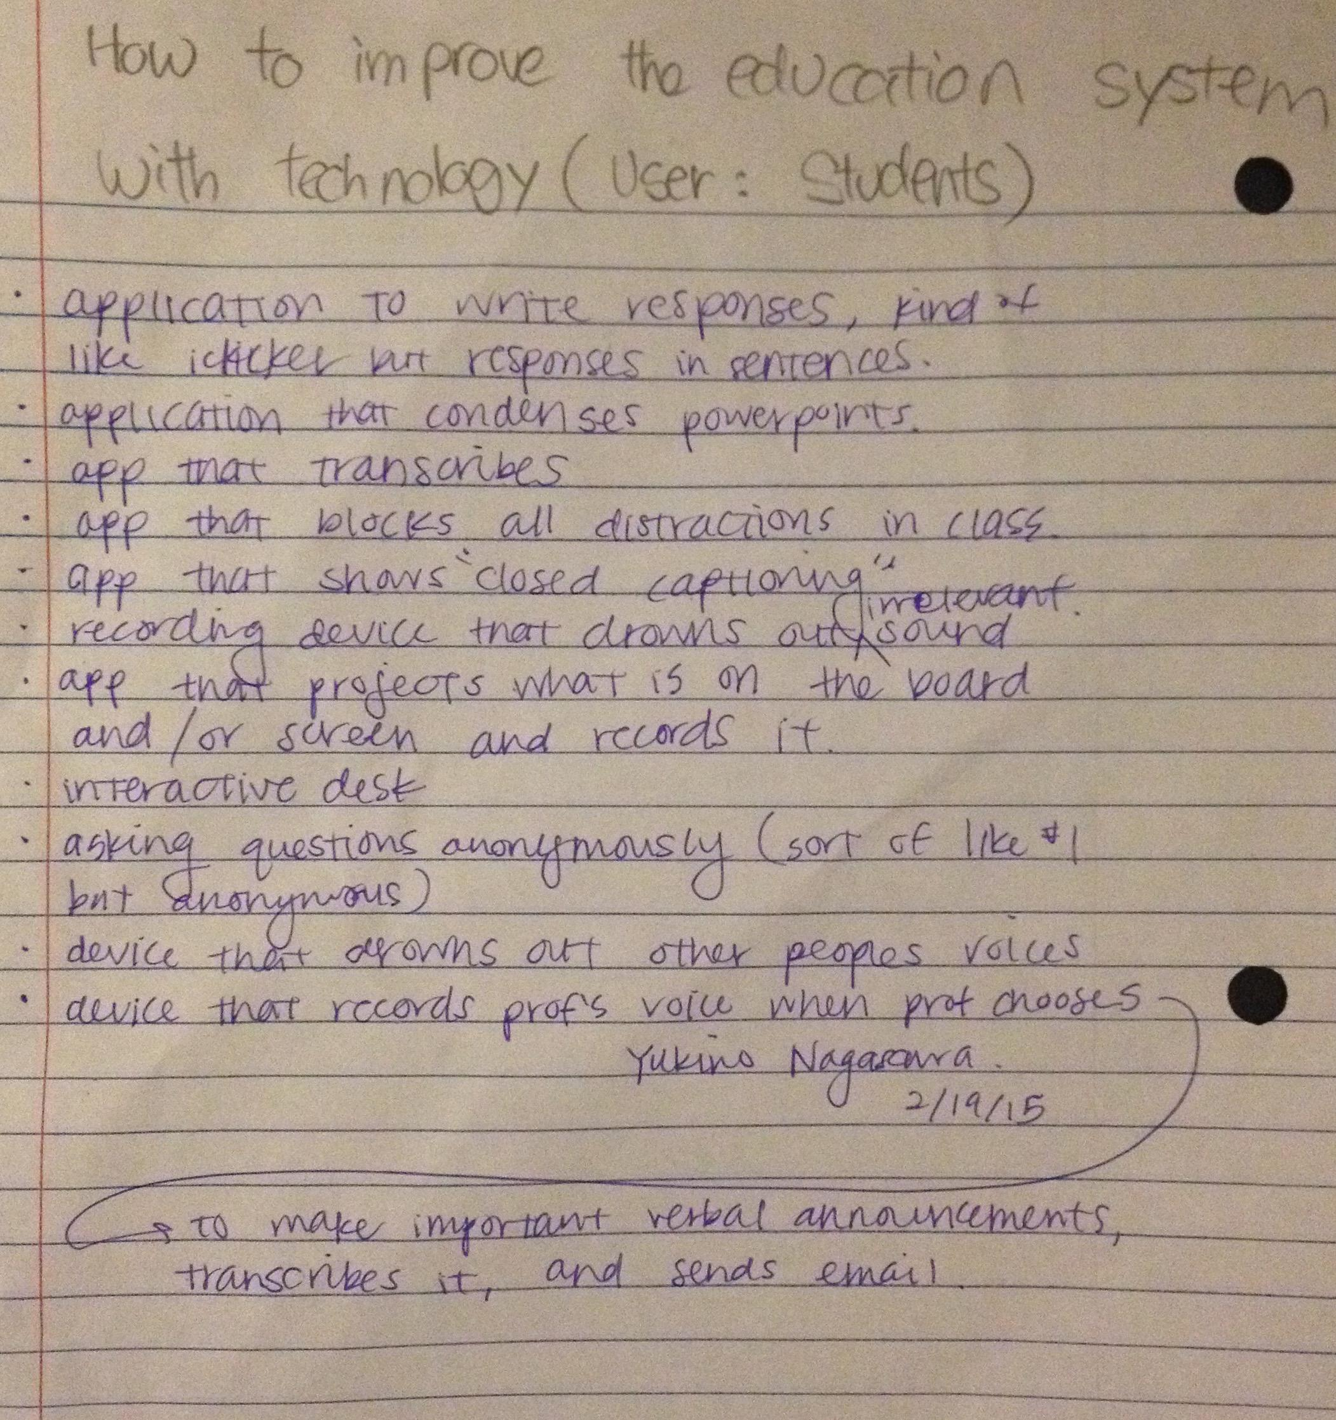

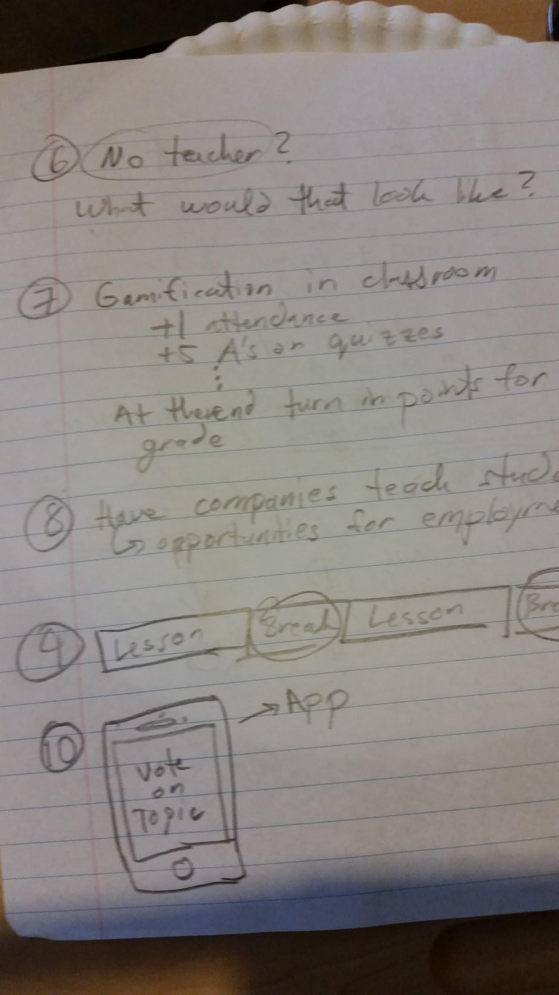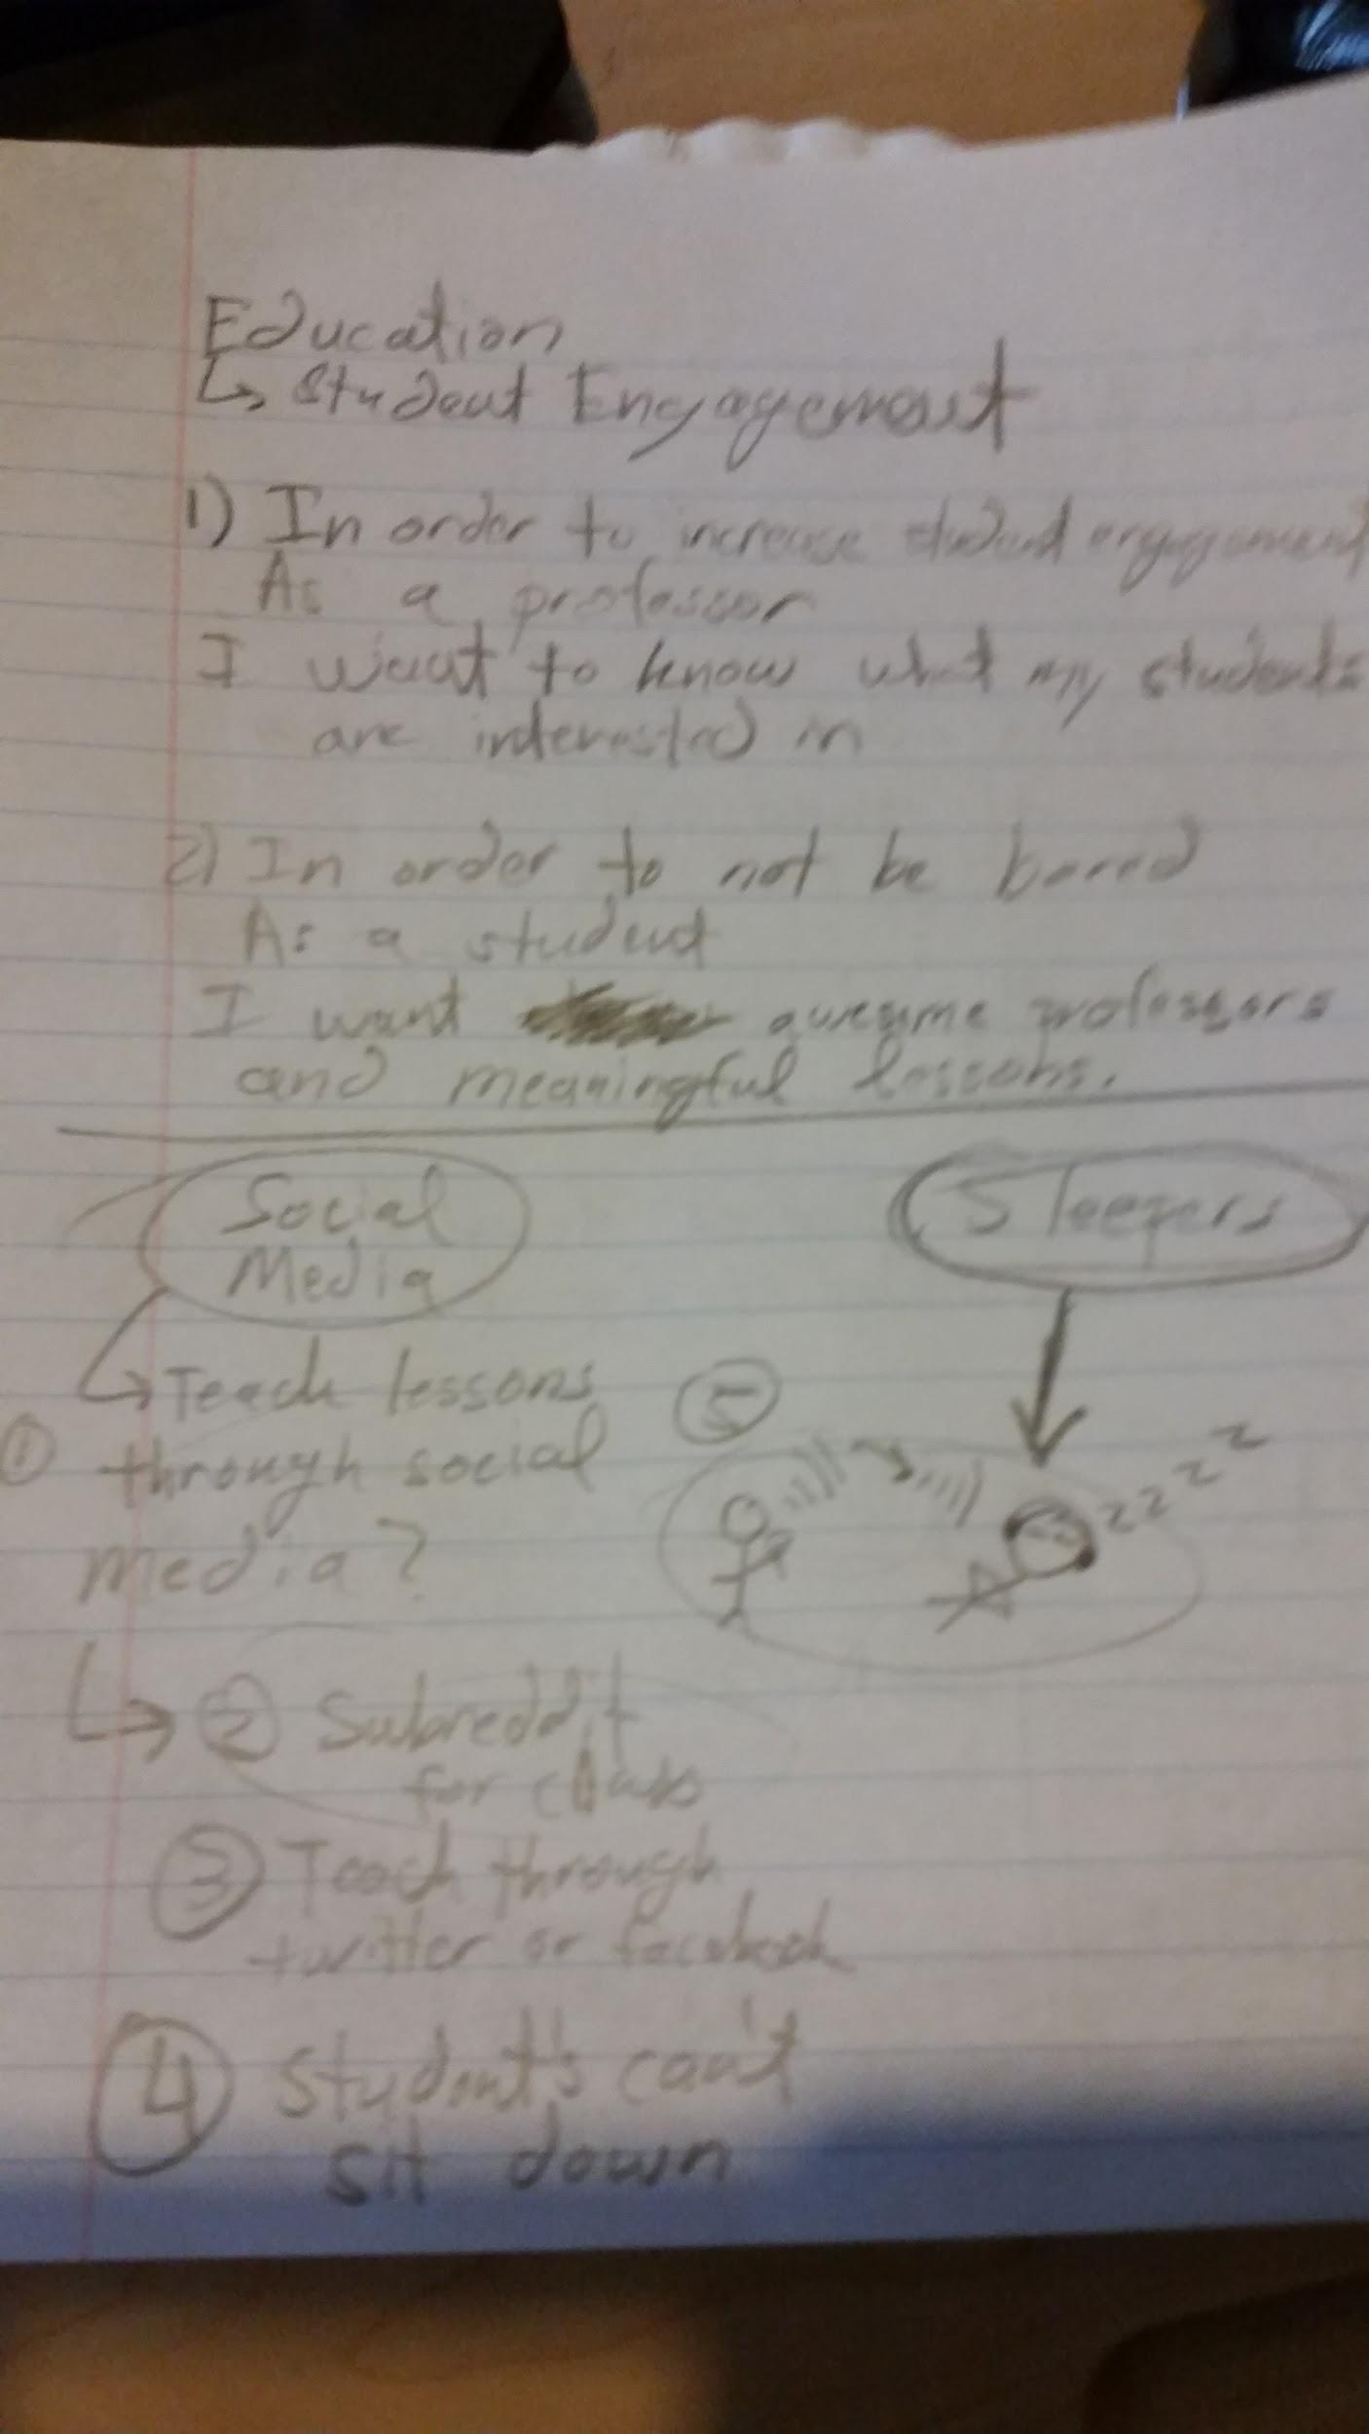

PART 2: Brainstorm Reflection

Brainstorm session two was built off of brainstorm session one. In brainstorm session one, we flushed out which key needs we would be interested in pursuing, and by session two we were able to solidify our ideas into a more systematic issue to address. For brainstorm session three, we were able get input from others not tied to our project. It was interesting to hear how they viewed our topic from a new perspective. There was also some overlap in the ideas that the non-group members suggested, that we had already flushed out and thought through. Session two was the session that solidified our direction for the remainder of the project, however it was still important to get the viewpoint of outsiders. When there is overlap between the outsiders ideas and your own it helps solidify your decision to pursue that idea further.

When doing brainstorming in the the future it would be important to come to the session with the tools to display the ideas clearly, such as images or post-it notes. A brainstorming session would also go better with a white board so ideas can be changed and moved around easier. It would also be interesting to see what brainstorming software is available to stream line to process, so that more time can be spent talking about ideas and less about the recording of information.

PART 3: User Needs and Requirements

User issues that need to be addressed in order to improve education along with some possible solutions:

* *Engagement* - We felt that engagement is a key topic to improving education. When a student feels excited about learning they tend to participate more, and in turn retain more information about the particular topic. Engagement is also a tough topic to address. With the influx of distractions, keeping a students attention focused on one topic is becoming ever more challenging.It is important for us to rethink the way information is presented, so that the student is willing to stay engaged. Below are some potential solutions we are in the process of reviewing:
  + Hands on Tools
    - Games
    - Augmented Reality
    - Digital Media
  + Professor Involvement - We did not want to place all the blame on the professor for why students don’t stay engaged but we did want to think about ways teaching habits could be modified in order to capture student attention for longer periods of time. From our interviews we highlighted key complaints about professor’s behavior and determined that there was commonality in these behaviors, such as reading off powerpoints and lack of asking for student feedback. Below are some possible solutions we will be exploring to improve a professors involvement with his/her class.
    - Interactive Environment
      * Digital Class Participation System
        + ‘LIKE’ tools
        + Add comments on lecture in real time
        + Ask questions in real time
  + Classroom Layout - We feel minor changes could be made to the classroom setting to improve student involvement, and have them feel apart of the class.
    - Large LED screens in lecture hall
    - Professor in center of lecture hall
* *Resources (lack of)-* As students ourselves we are aware of the issues facing students when it comes to the cost of education, living expenses, and transportation availability. Through our interviews we discovered many other issues that we ourselves do not face as well. These issues are much tougher to address because the usually involve government, and other regulatory bodies to address. Below we listed the three main issues we uncovered through our interviews and gave possible high-level solutions.
  + Education Cost
    - Tuition
      * Scholarship Opportunities
    - Parking Fees
      * More reasonable prices
      * Public Transportation
  + Living Cost
    - Rent
      * Affordable Options
  + Transportation Cost
    - Public Transportation
* *Support System*- You often hear on the news and read online, about the lack of proper mentors, and role models for students in primary and secondary schools. We also discussed though that there is also a lack in the higher education levels. Because students are seen as ‘adults’, they are often assumed to no longer need guidance. We feel that it is still important to provide university level students with positive mentors ang guidance.
  + Mentors and Role Models
  + Parents
  + Administrators
  + Community Support

The above user needs and requirements were flushed out over the individual interview sessions and the first two brainstorming sessions. We thought heavily about the issues students face in obtaining an education. For much of the brainstorming sessions we focused on the college level education system, however many of these needs a prevalent in the lower education levels. These needs are some of the most basic, yet some of the most complicated to address. Many issues in education are systemic of societal issues. A repeating topic we discussed was the lack of student engagement, we feel there is no simple silver bullet way to solve this issue, but as we progress with this project we will try to design a system, may it be a game or some other interactive tool that can address the issue of student engagement. Two other topics we frequently discussed was professor involvement, and classroom layout changes. Although both of these topics can be handled individually we have decided to encompass them under the umbrella term of student engagement. We decided on this because we felt it was the most logical flow of ideas based on our interviews,, brainstorming, and classmates inputs (from brainstorming 3).

PART 4: Alternative Ideas

The three design alternatives we are choosing to pursue further: classroom layout/design, interactive lectures, and games (as referenced in brainstorm_notes2.jpg). We came up with a class layout that includes a large screen centered in the middle of the classroom suspended safely by the ceiling with a 360 degree viewing angle. This solution will hopefully tackle the problem of student engagement in the classroom, by making the student feel more apart of the classroom. We were thinking of engagement in more general terms than just in academia and thought of the music industry. The contemporary music industry makes a majority of money by having large concerts (meaning that there is seating that is far away from the performer(s). To keep the audience engaged, many concerts of this magnitude have a huge screen displaying a close up of the performer(s). We figured that this system could be implemented in classrooms with the intent to create the parallel effect as it would have at a concert. The next solution of interactive lectures was founded purely through observations of the traditional teaching style. For more than five hundred or so years, teaching consisted of one central being lecturing to an audience, as the audience patiently sits and tries to understand the material. This inherently discourages engagement in the classroom, and so we thought of creating a software system that could keep the class engaged in real time, and possibly include constructive competition which we believe will increase learning. In tandem to this idea, we believe the solution of having a learning game that is played during class, can further keep students engaged during a lecture. Games can create constructive competition, fun, mental acuity stimulation and most importantly, engagement.

Classroom Layout satisfies engagement but it also satisfies the user need of resources. It does so by enabling classroom size to be large, so that all students can get into the classes they need and avoid unnecessary additions to the estimated time to graduate (which costs more money). By adding a constructive competition dimension, students can take comfort in the support of their teammates, and use the collective collaboration to the full advantage.

Interactive lectures provide a solution to the user need of resources by eliminating the need for individual classroom participation equipment/software. An example of this would be eliminating “iClickers” from college institutions that would: cost students money, create a need for batteries constantly, and create unfair penalties to the students that show up to class but lose points because their “iClicker” ran out of batteries or they had simply forgotten it. If the classroom had built-in features to keep students engaged, it would save resources for the students. Interactive lectures also create a forgiving support system, that each professor can have freedom to customize the experience, so that students can really feel the extra value added to a particular class.

Synonymous to Interactive Lectures, Games can eliminate resources like “iClickers”, lab materials, and etc, ultimately saving students a lot of money, time, and effort. Games can also create a support system based on teams, opponents, or any in-game design that promotes teaming/supporting. We could impose a reward system and a leaderboard in the classroom, instead of the traditional grading system alone. Our present grading system penalizes students for not doing their work and which results in students feeling as if they are enslaved. Extra points can be given to those who come up with the best algorithm for an assignment or acts of helping other classmates. Points will be then counted and posted on the leaderboards that can be viewed publicly by the whole class. This motivates the students to take an extra time to do more work and does not penalize those who did not. Although all aspects of this may not apply to our reasoning,it is a common belief among psychologists that reward based systems tend to work better than punishments. We understand that it is necessary to have a grading system, we also feel that other avenues need to be explored in order gauge the true knowledge retention of the student.